Title: Milestone 5

Author: Jason Hatfield

Course: CST-291

Date: May 31, 2023

Instructor: Professor Bobby Estey

### Introduction

I propose developing an engaging online movie database application tailored to film enthusiasts and casual moviegoers. Users can browse new film genres and conduct specialized director and title searches. The app's user-friendly layout will make movie information readily available, including release dates, star ratings, and narrative summaries. Additionally, the platform will let users contribute and modify movie entries, encouraging the growth of a collaborative library of movies that caters to various interests and tastes.

### Functionality Requirements

* As a user, I want to add a movie to my database, so I can keep track of movies I've watched or want to watch.
* As a user, I want to rate movies, so I can remember how much I enjoyed them.
* As a user, I want to categorize movies by genre, so I can easily find movies that fit my mood.
* As a user, I want to search for movies by title, genre, or director, so I can quickly locate specific movies in my database.
* As a user, I want to view movie details, such as release date, director, and a brief synopsis, so I can learn more about the movie.
* As a user, I want to update or delete movie entries, so I can keep my database accurate and up to date.

### Initial Database Design

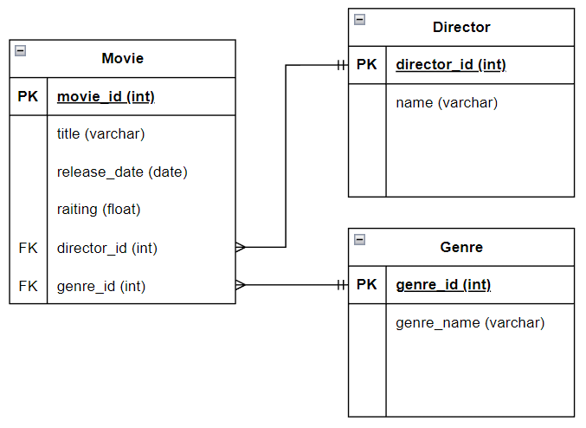

### 

### Initial UI Sitemap

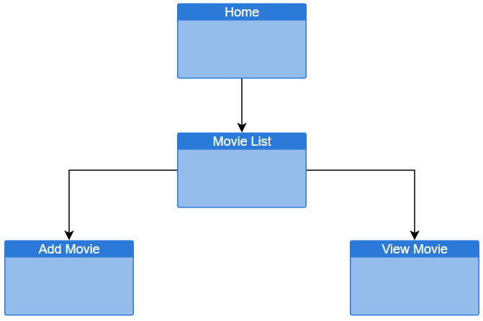

### Website Layout

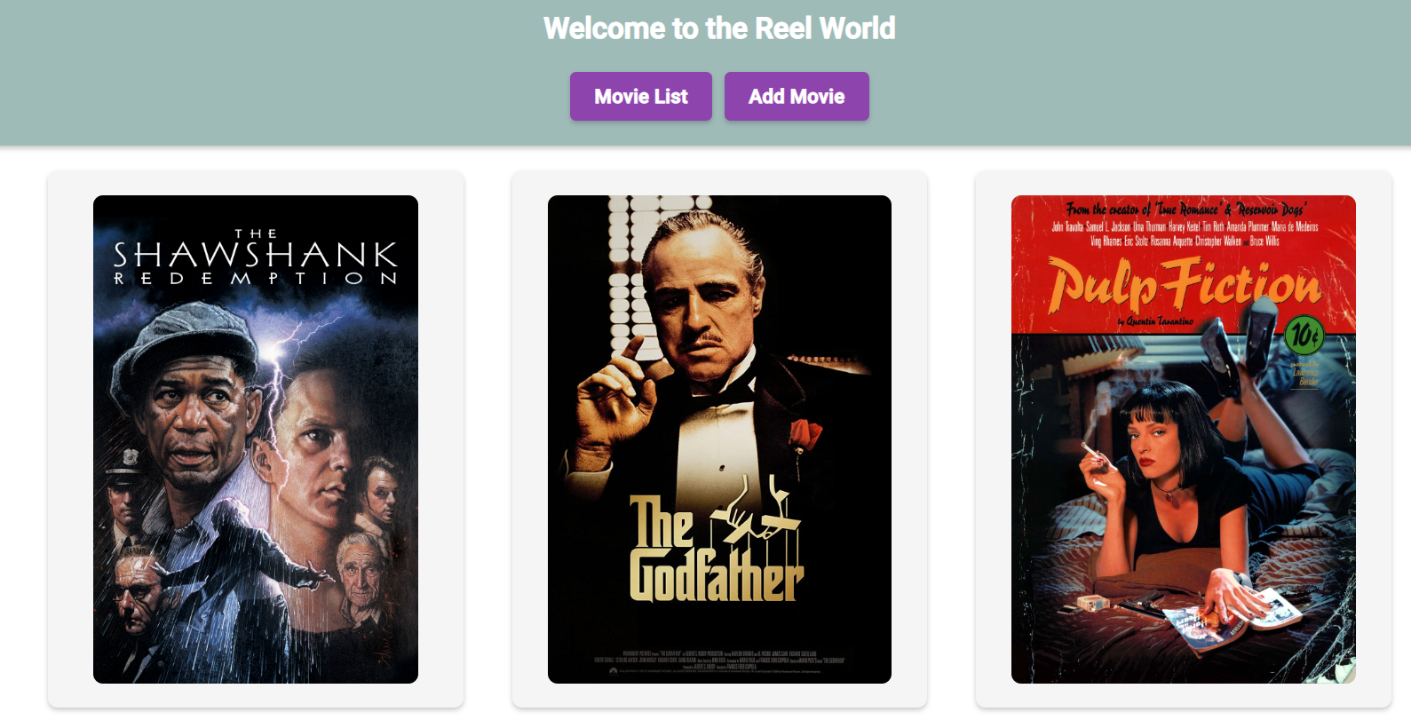

Figure Movie List

Figure Add Movie

Figure Movie Details

Figure Edit Movie Details

Figure Delete Movie Confirmation

### UML Class

### Risks

1. Risk: Limited familiarity with React and Angular frameworks.
   1. Mitigation: Allocate time for learning and reviewing resources and tutorials.
2. Risk: Complex movie search functionality.
   1. Mitigation: Break down search functionality into smaller tasks and ensure thorough testing.
3. Risk: Time constraints for completing the project.
   1. Mitigation: Set a realistic timeline and frequently review progress, adjusting as necessary.